Title (Arial 14 pts, bold)

Prénom Nom,^{1,*} Prénom Nom² (Arial 11pts, underlined)
ª Lab, city, country; ^{b} Lab, city, country (Arial 11 pts)
* email (Arial 11 pts)

Text (Arial 11 pts, line spacing 1.5)

The abstract must be in English, maximum one page

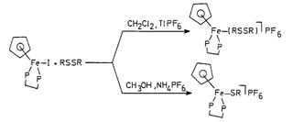
Figure 1. Image caption (Arial 10 pts, italic)

References
[1] Name, P; Name, P. F. J. Chem. 2004, 104, 139.

